Add a calculated Field and Sum field at the bottom
Step 1
Create the report
Step 2
Choose Data Set. Right Click and choose Add Calculated field

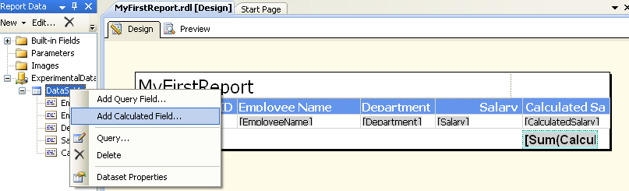
Step 3:
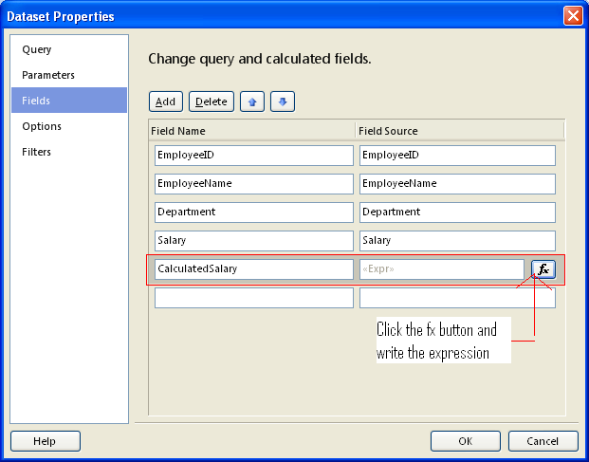
Step 4:
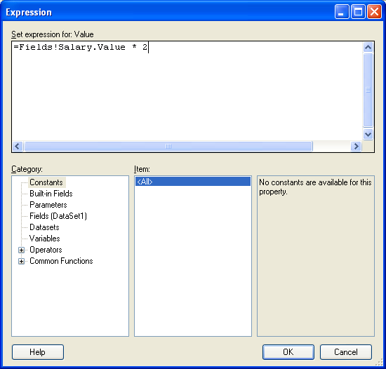
Step 5: To add the Summation field for the calculated column, Add a TextBox control.
Right click and choose Expression
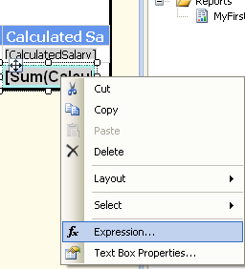

Step 6:
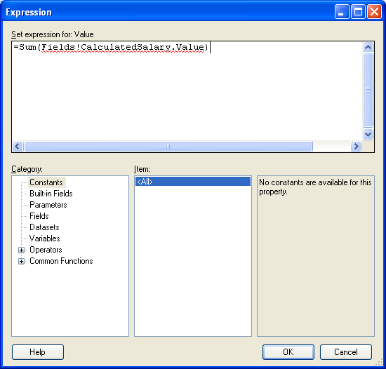

Step 7: The final output is
